Introduction

Instructions before joining the Workshop
- Students will be divided into groups of 4-5 students
- Each group should have at least 1-2 laptops
- Students must install Arduino IDE from: https://www.arduino.cc/en/software/
- After installing the IDE please download the workshop data from the github repo: https://github.com/hashircatto/CANSAT
- In the repo please copy the libraries folder and paste it into your documents/Arduino folder.
- Download the driver for the ESP32 board either from https://www.silabs.com/software-and-tools/usb-to-uart-bridge-vcp-drivers or from the Repo the file name is CP210x_Universal_Windows_Driver.zip
- Download and install the board support for ESP32 in Arduino IDE, go to board managers search for ESP32 and install the package from Espressif Systems, you must have quite fast internet support for it.
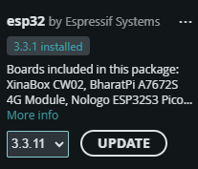
- Select ESP32WROOM DA board for programming
- Install Python IDEs like Pycharm or Visual Studio Code have preinstalled following libraries pycharm and mathplotlib.
- Please bring 1-2 micro-USB cables, it will make your life easier, but its not mandatory.

This step-by-step guide walks you through the complete end-to-end CanSat Workshop workflow for:
- acquiring sensor data at appropriate sample rates,
- timestamping it, packetizing and wirelessly transmitting it from the CanSat,
- receiving it with the ESP32 Ground Station,
- forwarding the packets to your PC over the COM port,
- displaying or processing them in the Python GUI,
- and logging everything to CSV.

Before you begin, make sure you have the following:
- CanSat hardware
- Ground Station hardware
- Arduino toolchain installed and configured
- Python with pyserial and matplotlib installed
- Codes and Supporting Material from https://github.com/hashircatto/CANSAT

Setting Up the Ground Station to Receive and Show Packetized Sensor Data
In this step, you will set up your ESP32-based Ground Station to receive the packetized sensor data transmitted wirelessly by the CanSat. The Ground Station will forward these packets to your PC over the COM port, where they can be processed/displayed using the Python GUI. Connect your Ground Station to your PC to begin.

- MAC address of Ground Station. Navigate to the directory …\Resolve-Khi-main\ Ground_station_macAddress\. Open the file: Ground_station_macAddress.ino. Connect Ground station to your computer through USB cable and upload the code to ground station. If the upload is successful, the blue LED on the Ground Station card will start blinking. Open the Arduino’s serial Monitor by clicking in the upper-right corner of the Arduino IDE. The MAC address of the ground station will be displayed in the Serial Monitor, similar to the example shown below.
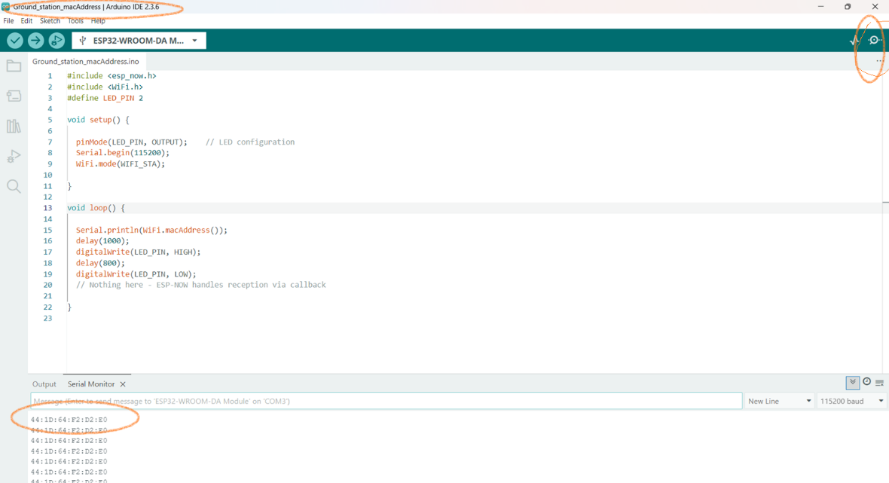
Figure 1: Ground Station Mac Address

In this case, the MAC address is 44:1D:64:F2:D2:E0. Note Down this MAC address.
- Navigate to …\ CANSAT-REPO\Arduino\Ground Station Code - Interfaced with GUI\Ground_station_code and open the file Ground_station_code.ino in the Arduino IDE.

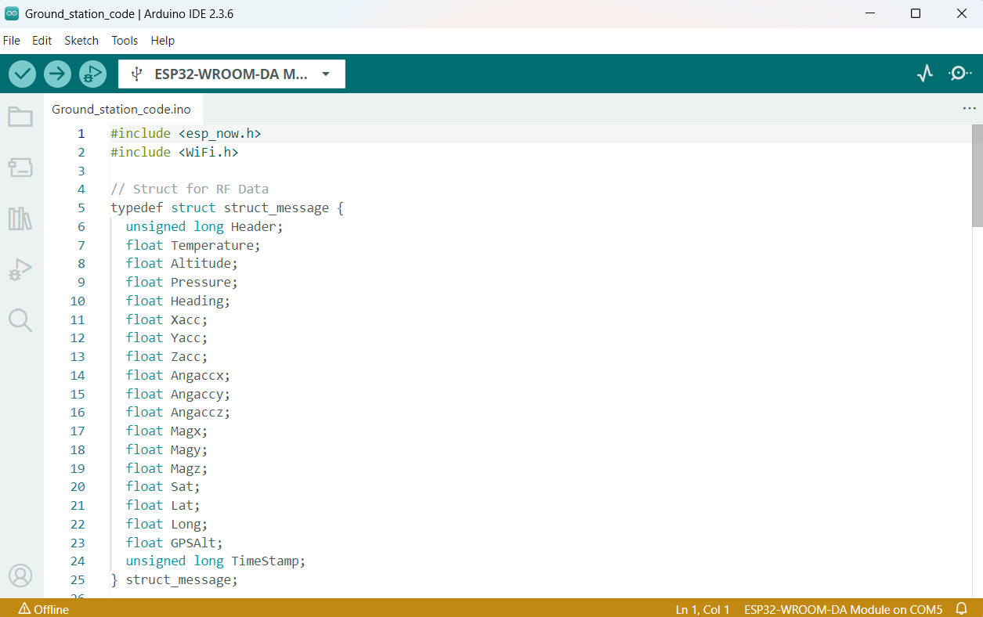
Figure 2: Ground Station Code
- Make sure that the correct COM port for your Ground Station hardware is selected, then upload the code to the ESP32.

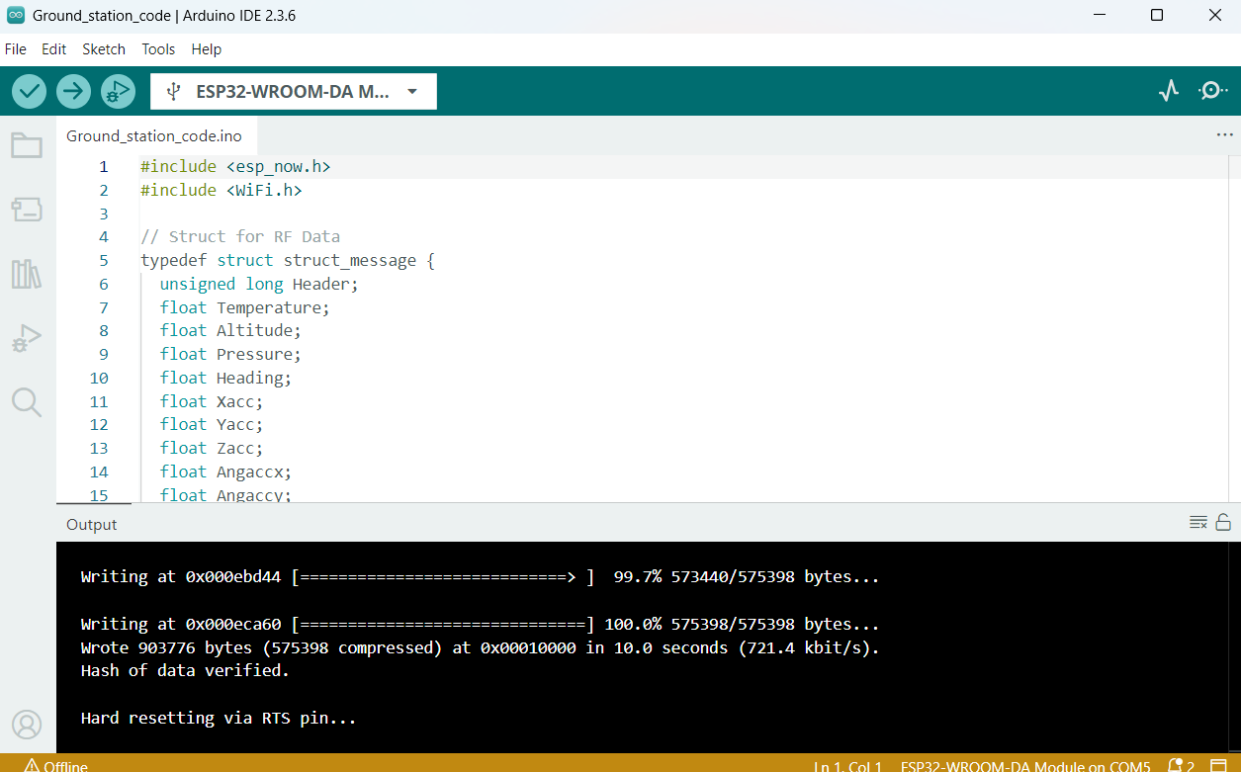
Figure 3: Uploading of Ground Station Code
- When the code is uploaded successfully, you will see
- the above message in Arduino IDE

Setting up Your CanSat for Wireless Transmission of Packetized Sensor Data
- Navigate to …\ CANSAT-Repo\Arduino\CANSAT Code - Interfaced with GUI\CanSat_Code and open the file CanSat_code.ino in the Arduino IDE.

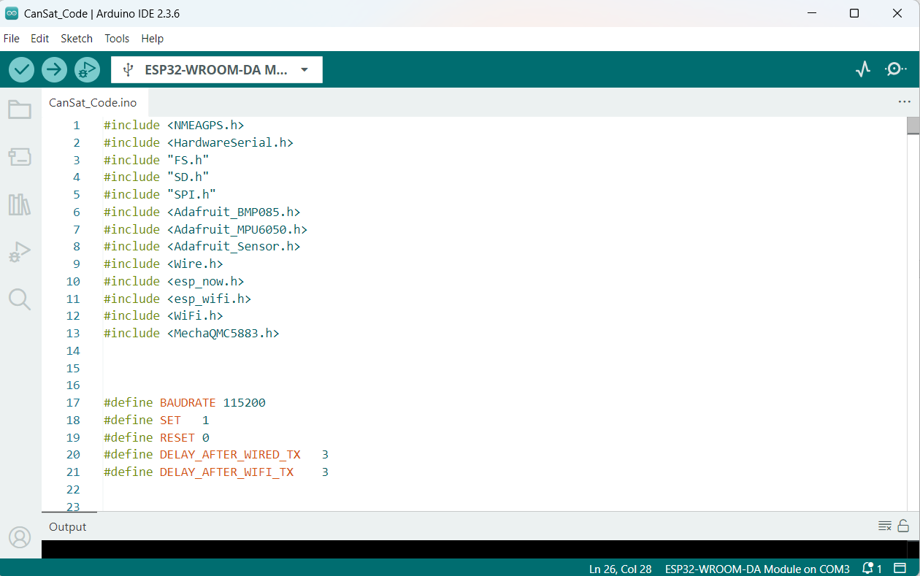
Figure 4: CanSat Code - Arduino IDE

- Embed the MAC address of your Ground Station (noted in the previous steps) into the code at lines ~60–65.
- Ensure that the correct COM port for the CanSat is selected, then compile and upload CanSat_Code to the board.

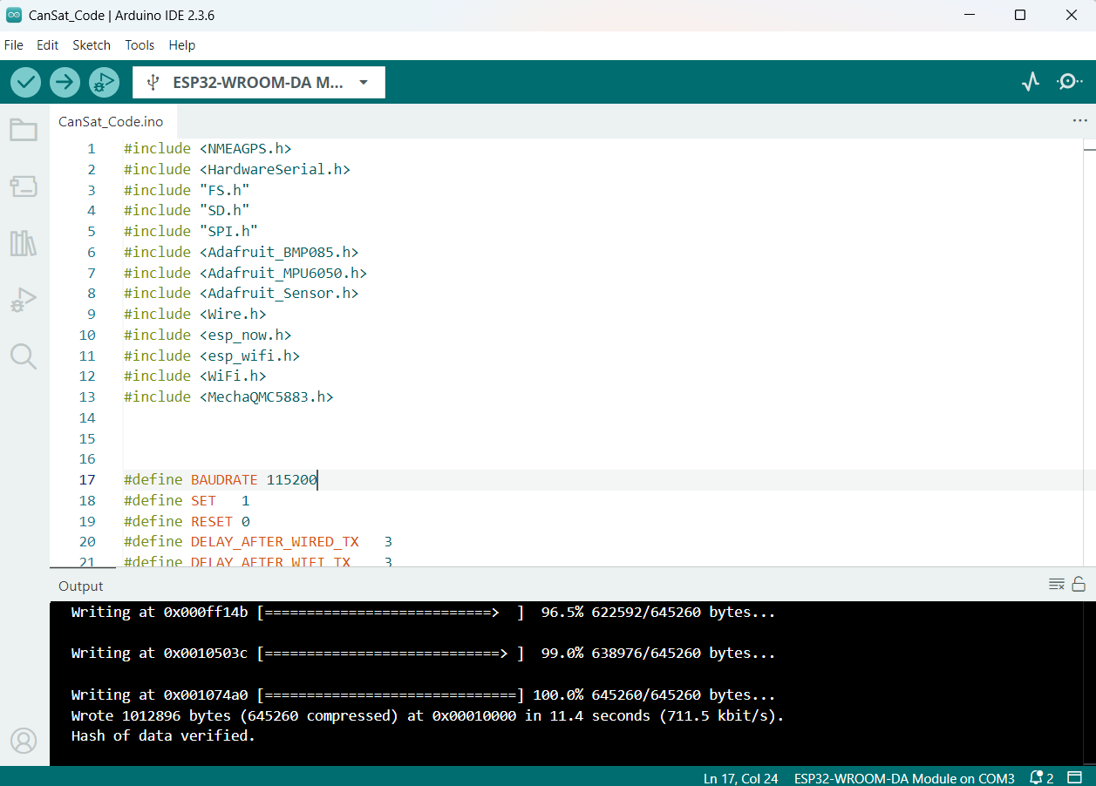
Figure 5: Uploading of CanSat Code

- When the code is uploaded successfully, you should see the above screen.
- Open the Serial Monitor in Arduino IDE at 115200 bps. You should see the following status messages. If these appear, it confirms that your CanSat is functioning correctly and transmitting data wirelessly, some of the messages will fail to deliver, but that’s ok, don’t worry about it.
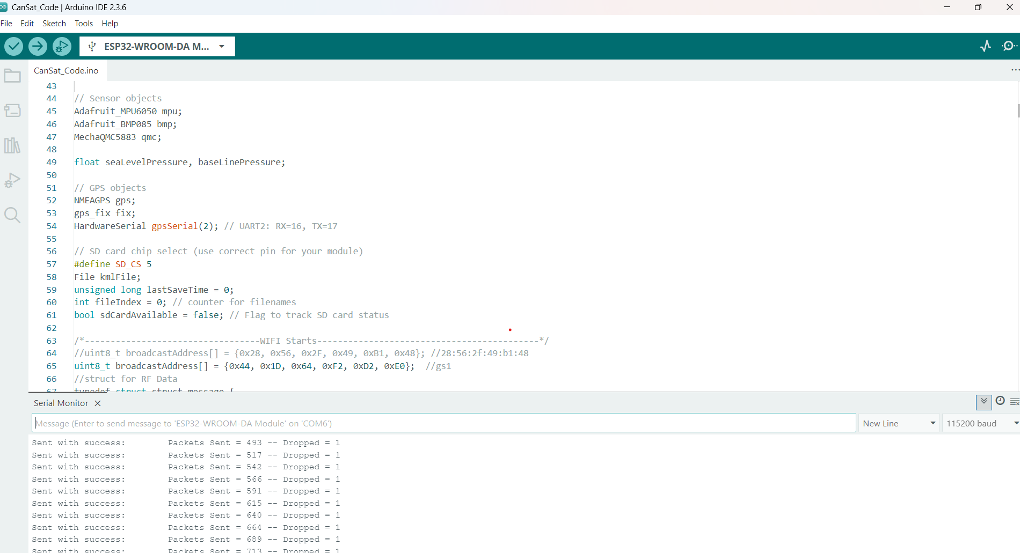
Figure 6:CanSat Status messages

- When the CanSat is transmitting data and the Ground Station is connected to your PC, the Arduino Serial Monitor for the Ground Station’s COM port (COM5 in this example) will display output similar to this.
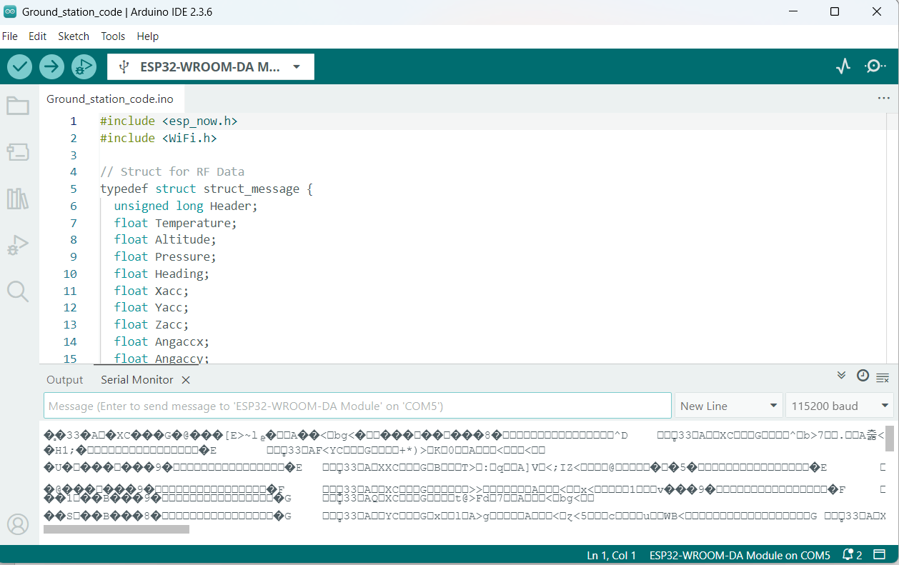
Figure 7: Ground Status Serial Monitor -- Displaying CanSat Packets in ASCII
- The serial monitor shows the ASCII codes of bytes received at the COM port of Ground station.

If everything matches the steps above, congratulations! Your CanSat is now transmitting packets wirelessly, and the Ground Station is successfully receiving them and forwarding them over UART to your laptop.
If you are encountering any problem, contact one of the experts.

Display CanSat Packets in the Python GUI Dialog Box
The next step is to receive the CanSat packets and either display/process them in the Python GUI.
Close all COM ports in the Arduino IDE. Then, navigate to …CANSAT_REPO\Python Data Read - With Calibration\ and open this folder in the terminal.
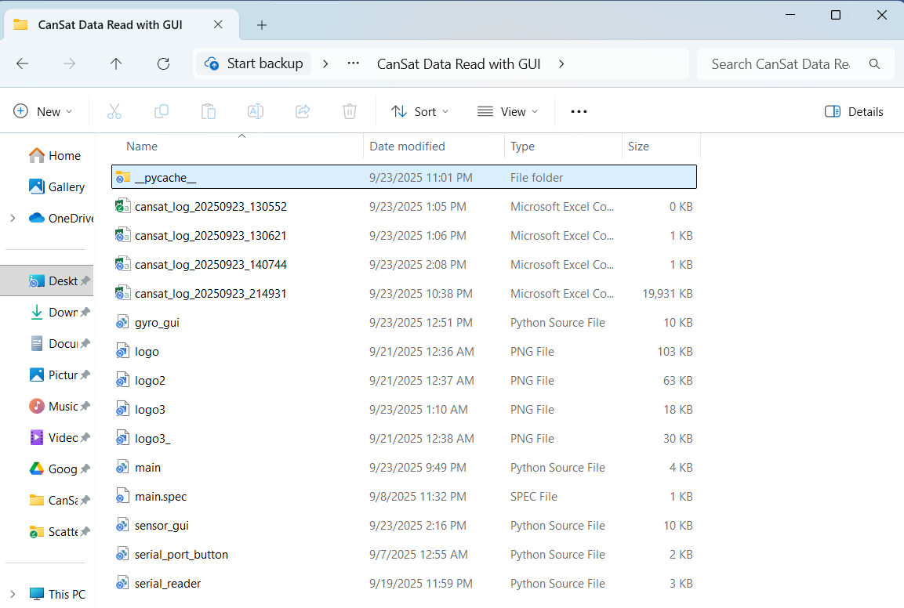

You may open the python GUI source files in VS code or any other IDE of your choice.
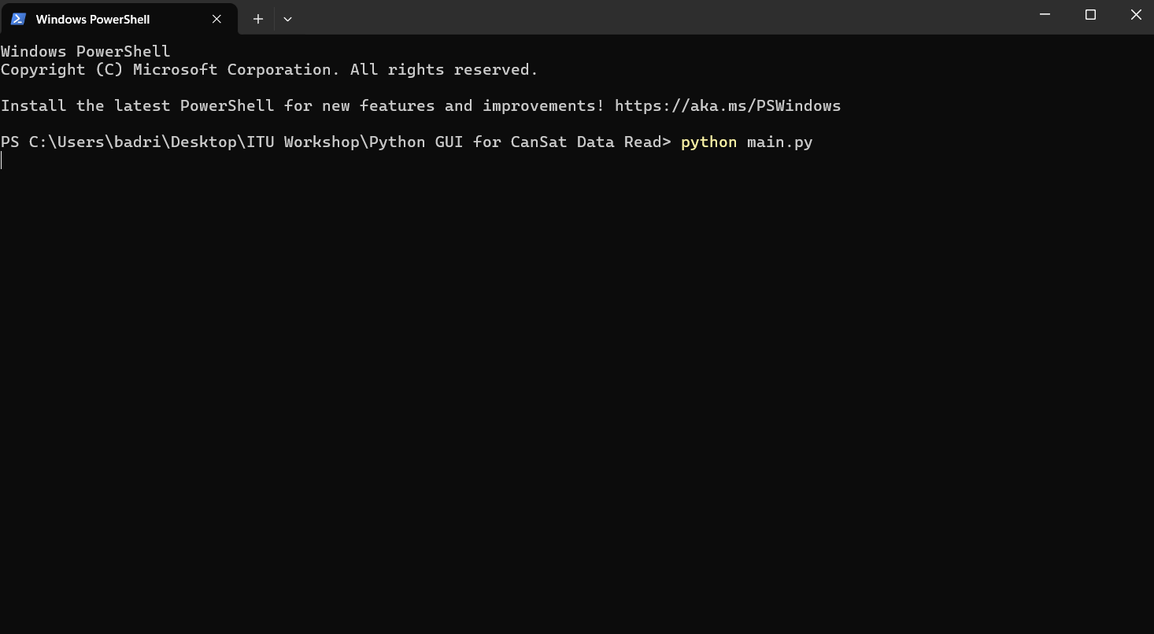

Choose COM Port:
After running python main.py, a window will appear with a drop-down menu listing the active COM ports. Select the port to which the Ground Station is connected, and then click OK
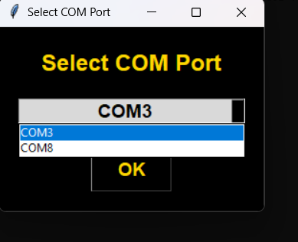

In this example, the Ground Station is connected to COM8. After you click OK, if the selected port is not already in use by another application, two windows will open: one displaying the RAW data, and the other showing only the bias-adjusted gyroscope data.

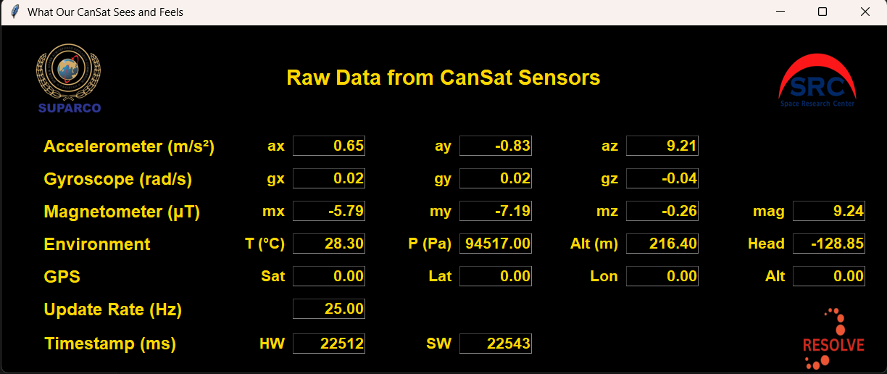

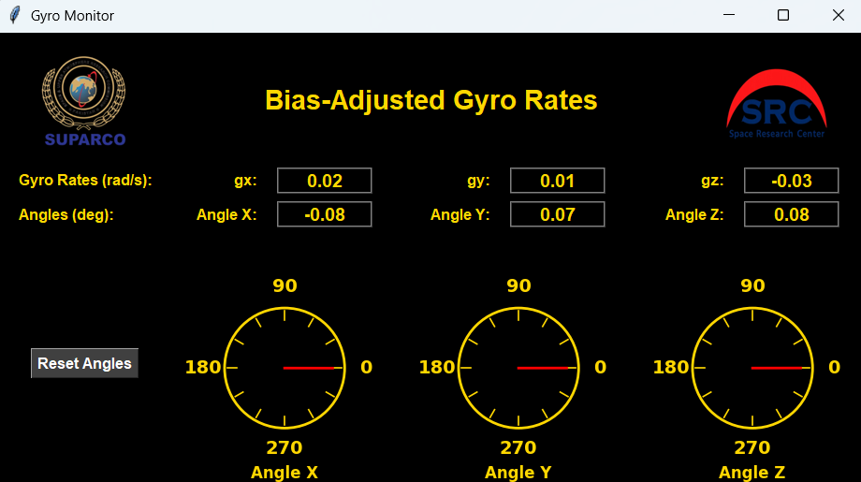

If you see the above two windows, it means your GUI is ready to receiving and display data.
Once the Ground Station and GUI are ready, power on your CanSat—either (1) via the USB cable, or (2) using the battery and power button. You should now see live data streaming in the GUI windows, as shown below.
Congratulations, your end-to-end system is working.

If you don’t see any data being updated, please double-check the following:
• The correct Arduino code has been uploaded to both the Ground Station and the CanSat.
• The correct MAC address is embedded in your CanSat code.
• The Ground Station is powered on and ready to receive data before powering up the CanSat.
• The blue LEDs on both the Ground Station and CanSat ESP32 boards are turned on.
• The correct COM port is selected in the Python Receiver GUI.
If all of the above steps are performed, ask any workshop expert for assistance

Analyzing Logged Data
Each time the Ground Station is powered on, it stores all received packets in a CSV file. This file is saved in the same folder as the Python source code. The naming convention is cansat_log_data_time.csv. For example, the screenshot below shows three CSV files: cansat_log_20250920_141021.csv, cansat_log_20250920_141043.csv, and cansat_log_20250920_141103.csv

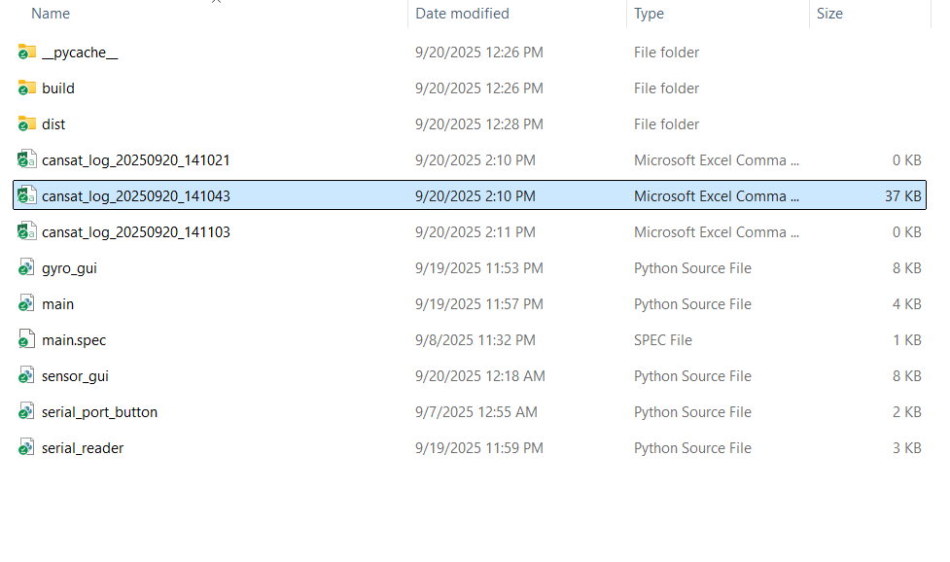
This is how your CSV file appears: each row corresponds to a single packet, containing both the hardware timestamp (generated by the CanSat) and the Python timestamp (when the packet is processed on the PC). The columns are labeled according to their respective sensors—for example, ax, ay, and az represent accelerometer readings. The remaining columns follow the same self-explanatory naming convention.
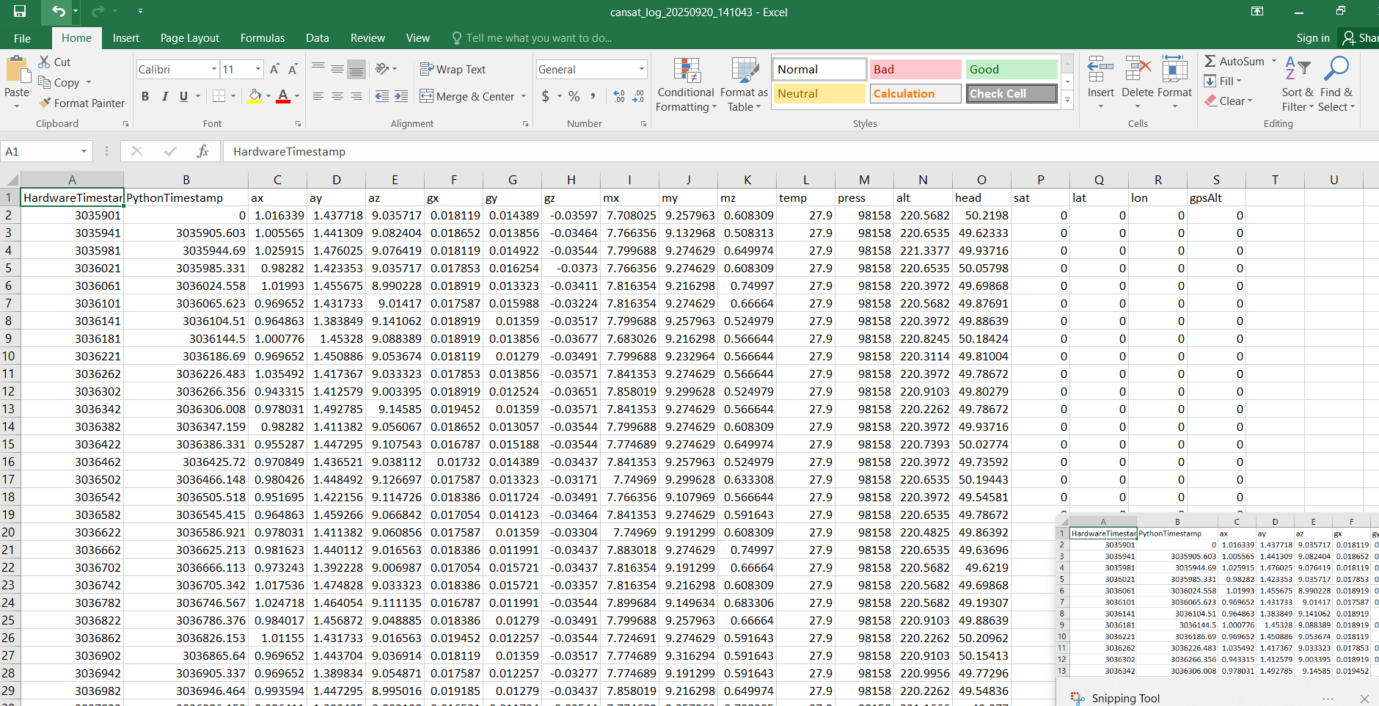
Figure 8:Sensor Data logged in csv file

Familiarize yourself with the log file, as it is where all data from your CanSat flight will be stored.

Make sure the CanSat battery is fully charged before the flight test. A fully charged battery typically lasts only 15–20 minutes.
CANSAT stored data can be passed through a filter, we have specially designed a magdwick filter, to analyze your data type in <python madgwick_filter.py cansat_log_20260915_180014.csv> in command prompt or python environment. It will generate a PNG file titled: madgwick_offline_test.png. Open the image file to check your satellites’ orientation etc.

